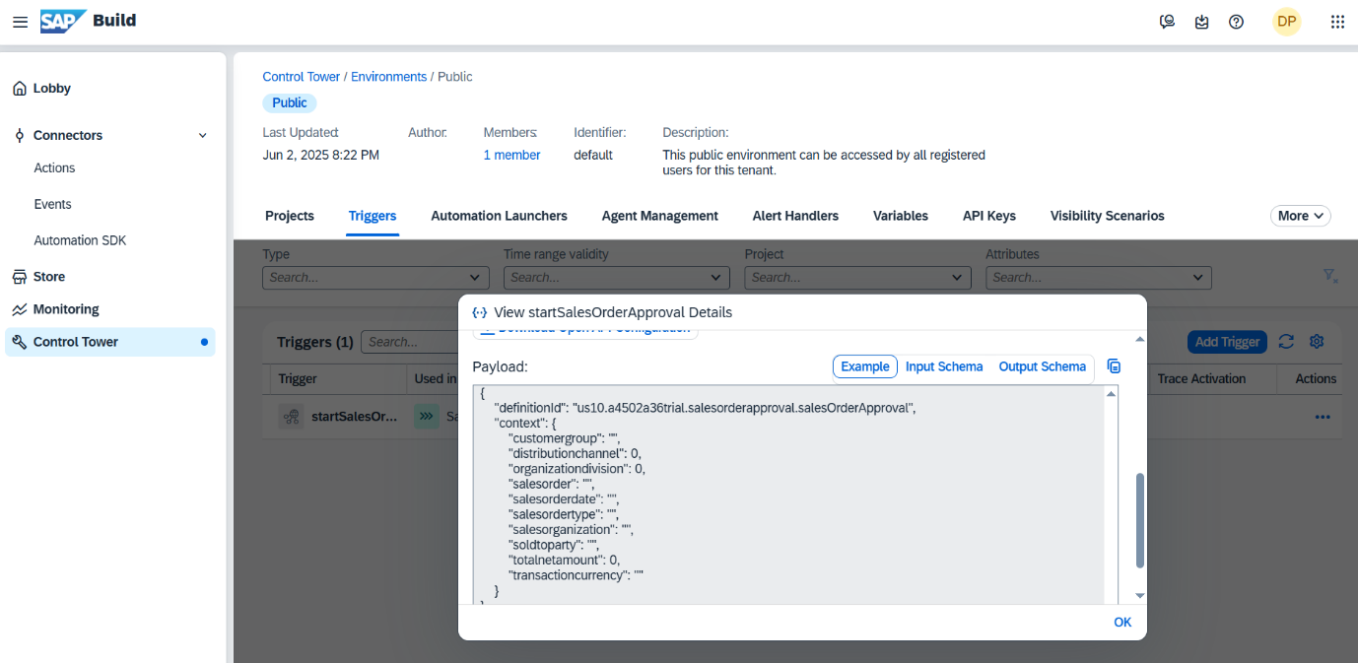
Open post man and use the API which you have created in the BPA.

See the below API calling method in the postman app
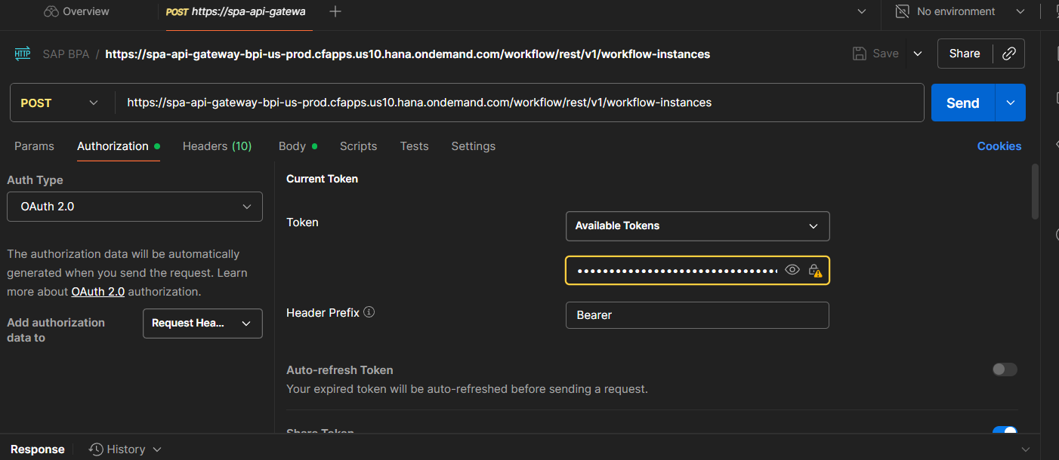

Use OAuth 2.0 and used Bearer in Header Prefix.
Pass the credentials from the BPA key and also BTP login.
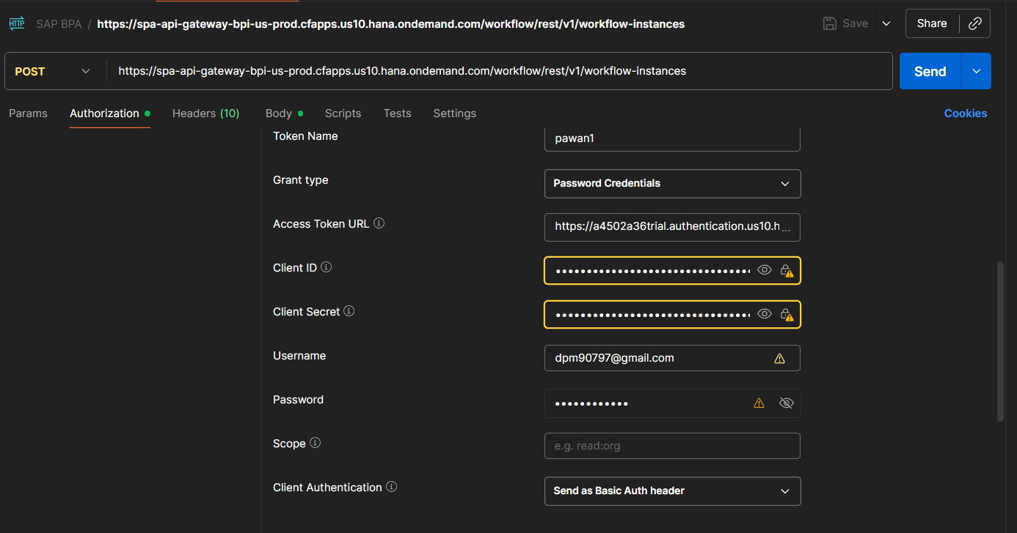
And generate the Authorization Token
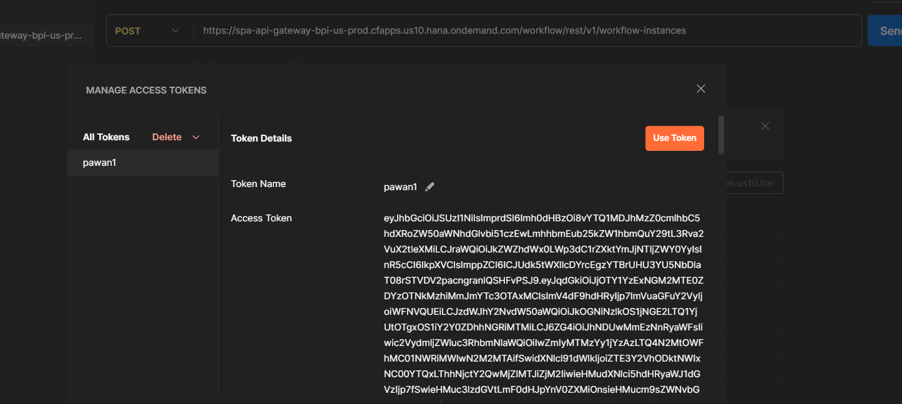
Use the token and
As the above 1 image has the context.
Pass that same payload in the body.
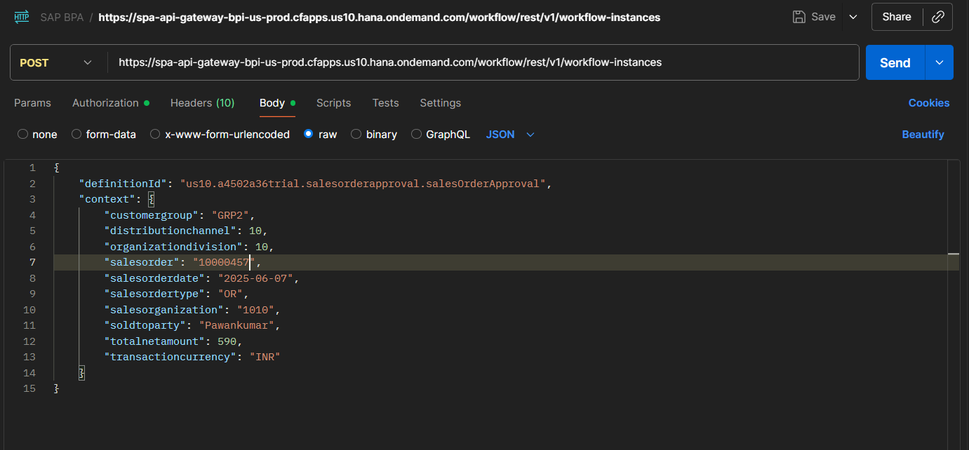

Then do the post call.
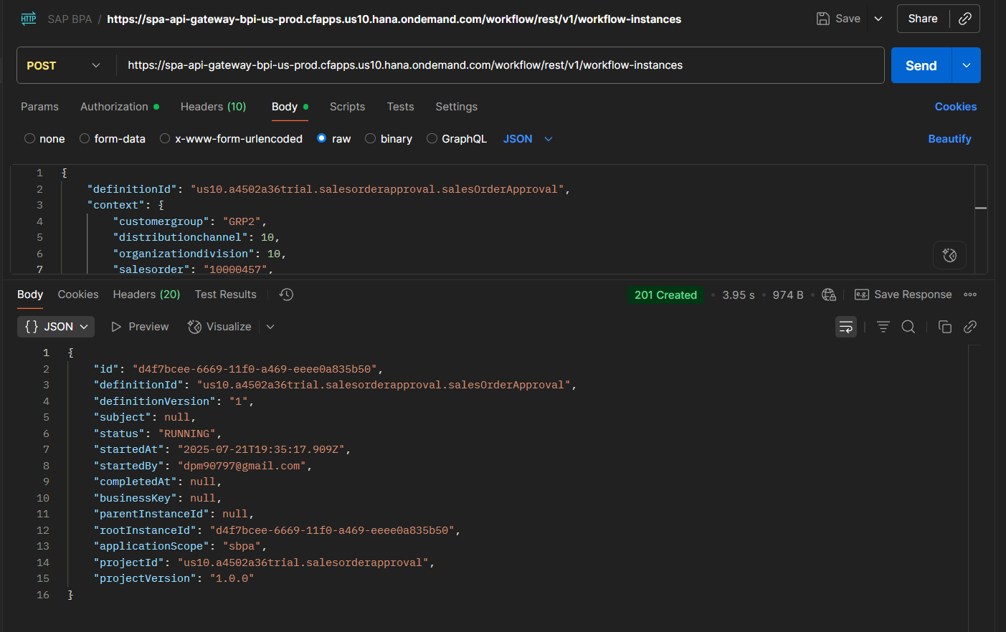

Completed.

